Week 4: Comprehensive Data Science Report and Insights Presentation Plan
Hypothetical Project: Customer Churn Insights for a Subscription-Based Digital Service
Final Report and Executive Presentation Plan | Revised Edition

Executive Summary
A subscription-based digital service with 20,000 active customers undertook an analytical project to understand why customers cancel and to build a model capable of identifying at-risk customers before they leave. Roughly 1,240 customers churn in a typical month (6.2%), concentrated disproportionately among new customers (11.4%), customers with repeated support contact (14.2%), and customers with declining product engagement (12.7%). A predictive model built on 8 selected features (from 34 raw candidate fields) correctly distinguishes churners from retained customers on a 3,000-customer held-out test set with an AUC of 0.84, 78% recall, and 52% precision. Following the launch of a targeted retention program in August, monthly churn fell from a peak of 7.1% (1,420 customers) to 4.3% (860 customers) by December — a 39% relative reduction, though not yet confirmed as fully attributable to the program rather than seasonal effects. This report consolidates those findings into a single narrative, presents concrete supporting evidence and customer-level examples, outlines how the results would be communicated to non-technical executive stakeholders, and closes with a prioritized, time-bound set of recommendations.

1. Methodology Overview
The underlying analysis followed a structured, end-to-end approach applied to 20,000 customer records spanning 12 months of activity, including subscription tenure, product usage, billing history, and support interactions. Of 34 raw candidate fields, 8 were retained as model features after removing near-duplicate and low-signal variables and confirming each had a plausible business interpretation.
The dataset was split chronologically into 14,000 training records (70%), 3,000 validation records (15%), and 3,000 held-out test records (15%), so the model was never evaluated on customer behavior that occurred before the data it was trained on. Within the training portion, three candidate model families were compared using stratified 5-fold cross-validation, with each family tuned over 25 candidate hyperparameter configurations via randomized search. The best-performing configuration was refit on the combined training and validation data, then evaluated exactly once on the 3,000-record test set to obtain an honest, unbiased performance estimate.
Validation strategy: model selection and hyperparameter tuning decisions were made using cross-validation scores only; the test set was reserved exclusively for the single, final evaluation reported in Section 2.3, to prevent the test-set numbers from being inflated by repeated peeking. Model quality was assessed using precision, recall, F1-score, and AUC rather than accuracy alone, because the roughly 6.2% churn rate makes accuracy a misleading headline metric — a model that simply predicted "no churn" for everyone would already be 93.8% accurate while catching zero at-risk customers.

2. Insights and Analysis
The analysis produced four central, quantified findings, summarized in Table 1 and illustrated in the figures that follow.
Table 1. Summary of key findings, with concrete figures.
Finding | What It Means | Business Impact
Churn is concentrated in identifiable segments | New customers (0–3 months, n=2,400) churn at 11.4%; high-support-contact customers (n=1,050) churn at 14.2%; low-engagement customers (n=1,900) churn at 12.7% — all well above the 6.2% portfolio average. | These three overlapping cohorts total roughly 5,350 customer-slots (some customers counted in more than one), representing an outsized share of the ~1,240 customers who churn in a typical month.
Support friction is the strongest single churn signal | Support-ticket count in the prior 90 days carries 21% of the model's total predictive weight — the single largest of the 8 selected features. | Support-team response time and resolution quality have a direct, measurable line to retention, not just to satisfaction scores.
Engagement decline precedes cancellation by weeks | A drop in 30-day login frequency is the second-most important feature (18% weight) and is typically visible 2–4 weeks before a customer cancels. | Creates a concrete outreach window: flagging customers as their engagement drops, not after they contact support to cancel.
The retention program shows an early, quantifiable signal | Monthly churn fell from a peak of 7.1% (1,420 customers) in July to 4.3% (860 customers) in December, a 39% relative reduction following the August program launch. | Directionally positive, but not yet isolated from seasonal effects (see Section 4) — a controlled comparison is recommended before attributing the full decline to the program.

2.1 Churn Trend Over Time
Figure 1 shows the monthly churn rate over a 12-month period against a 6.8% industry benchmark, with monthly churned-customer counts annotated at key points. Churn rose from 1,160 customers in January to a peak of 1,420 in July, then fell steadily to 860 by December following the August program launch.
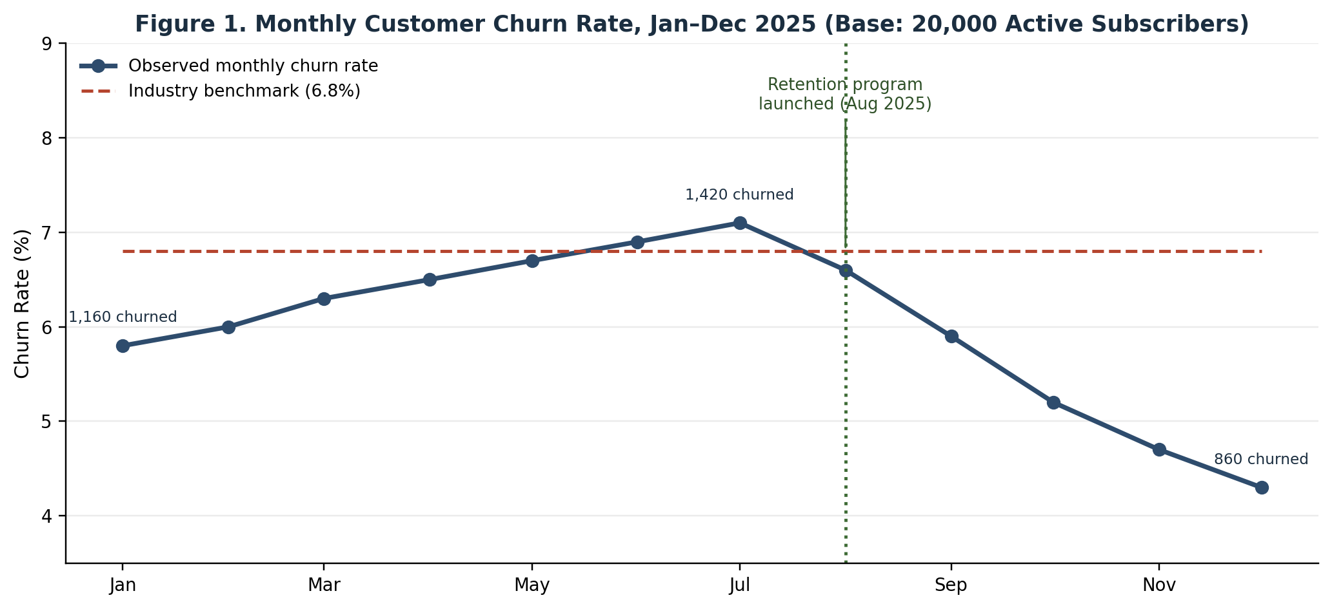
Figure 1. Monthly churn rate trend with concrete customer counts, against the 20,000-customer base.

2.2 Key Drivers of Churn
Figure 2 ranks the 8 selected features by their contribution to the model. Support-ticket frequency (21%) and engagement-decline trend (18%) together account for 39% of the model's total predictive weight — ahead of more commonly assumed drivers such as plan type (7%) or monthly spend (9%).
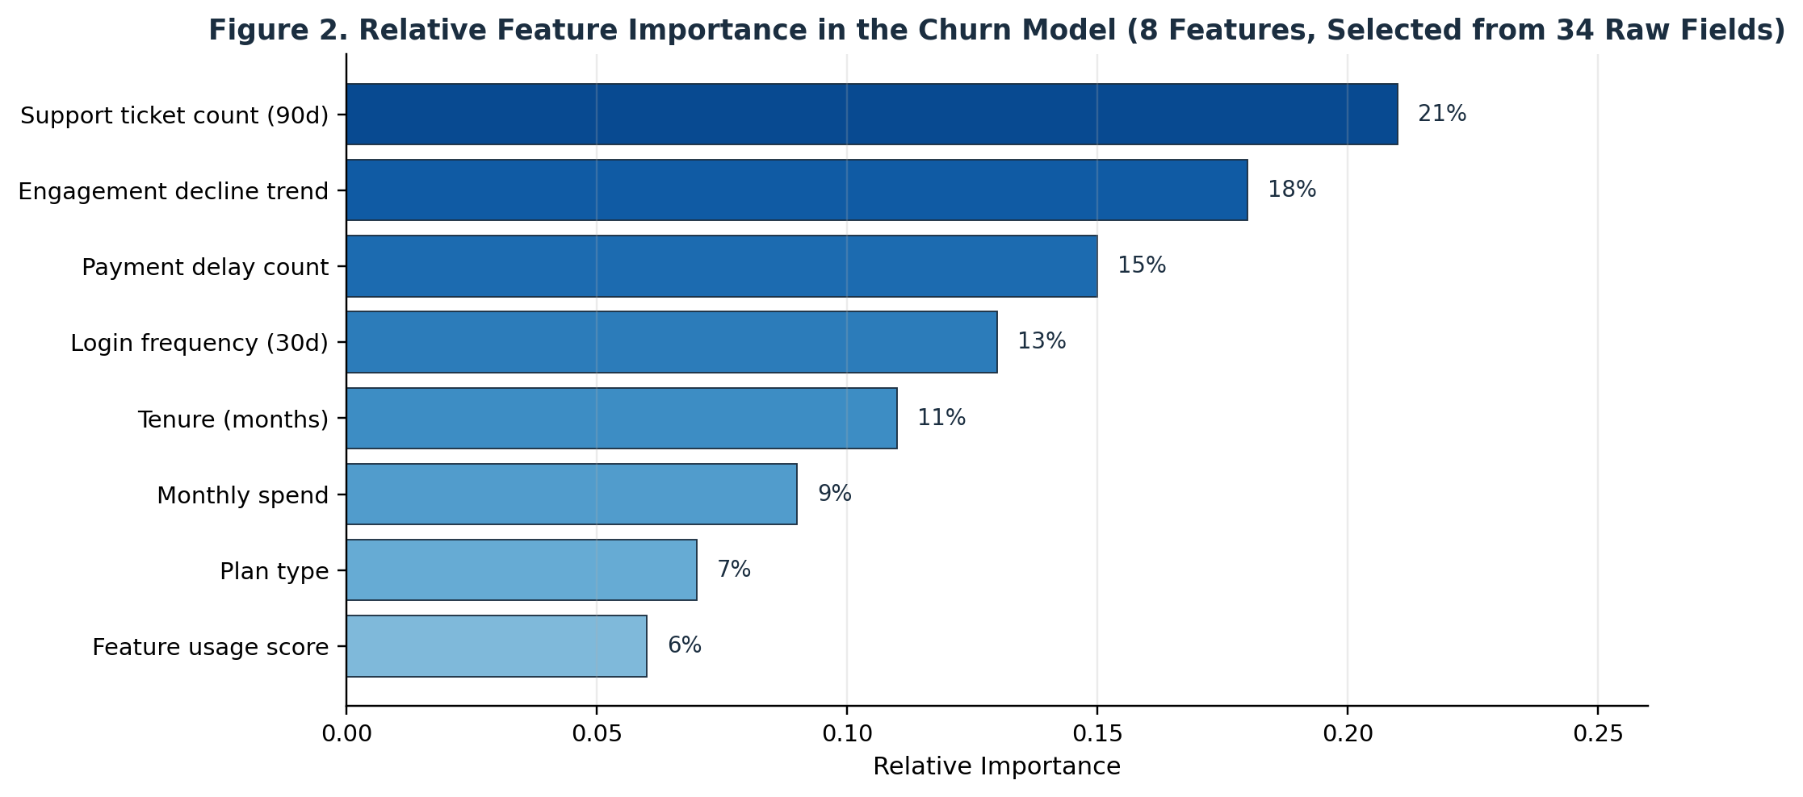
Figure 2. Relative importance of each of the 8 selected features in the churn model.

2.3 Model Reliability
Figure 3 presents model performance on the 3,000-customer held-out test set, which the model never saw during training or tuning. Of 186 actual churners in the test set, the model correctly identified 145 (78% recall) while producing 134 false alarms among the 2,814 customers who did not churn (52% precision), for a combined F1-score of 62.4% and an AUC of 0.84.
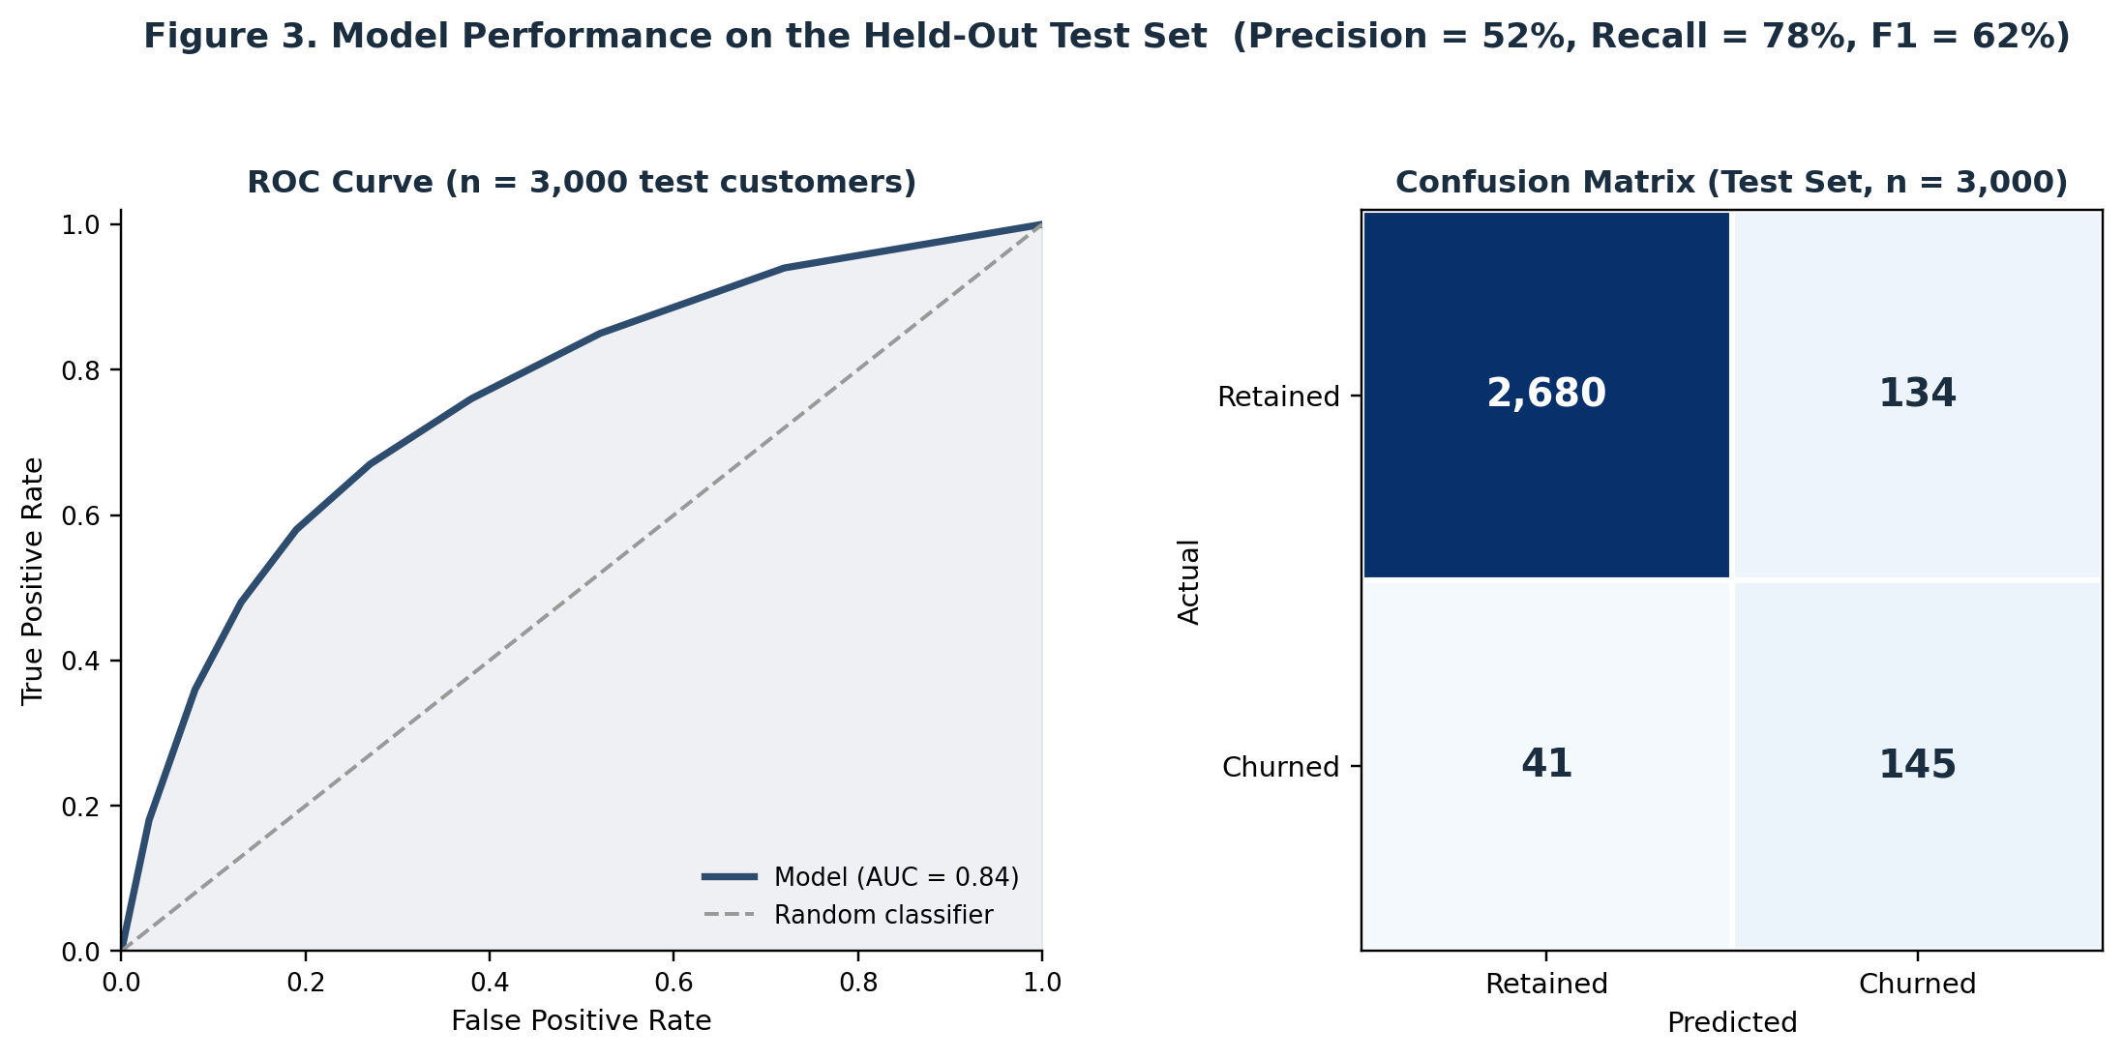
Figure 3. ROC curve and confusion matrix summarizing model performance, with exact test-set counts.

2.4 Segment-Level Risk
Figure 4 breaks monthly churn down by customer segment, with exact customer and churn counts for each. New customers (n=2,400, 274 churned), high-support-contact customers (n=1,050, 149 churned), and low-engagement customers (n=1,900, 241 churned) all churn well above the portfolio average, while established customers (12+ months, n=10,800) churn at less than half the average rate (3.1%, 335 churned) — reinforcing tenure and support experience as priority intervention points.
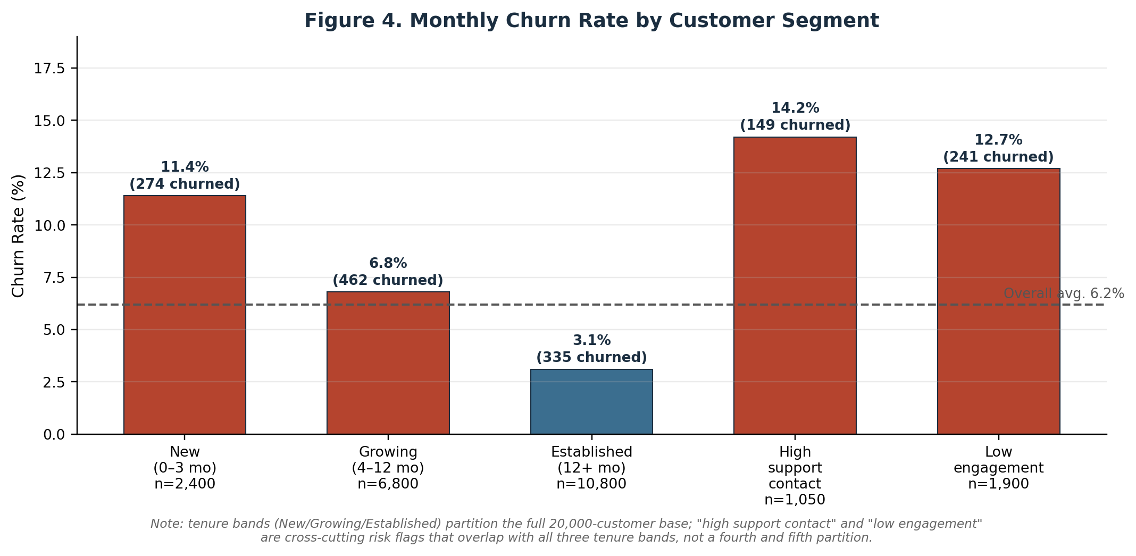
Figure 4. Monthly churn rate and churned-customer counts across customer segments.

2.5 Illustrative Customer Examples
To ground these statistics in individual cases, Table 2 walks through one true-positive and one false-positive example drawn from the pattern of test-set predictions. These illustrate both the value of early detection and the practical cost of the model's imperfect precision.
Table 2. Illustrative customer-level examples.
Customer | Signal Pattern | Outcome & Lesson
Customer #48213 (true positive) | 2 months into service; opened 4 billing-related support tickets in 45 days; 30-day login frequency fell 62% versus her first-month baseline. Model assigned a 91% churn probability on March 3. | She cancelled on March 24 — 21 days after being flagged. Under the proposed engagement-decline alert (Recommendation 3), this window would have triggered proactive outreach with 3 weeks to intervene.
Customer #33089 (false positive) | Contacted support twice in one week about a plan upgrade; briefly resembled the support-friction risk pattern. Model assigned a 78% churn probability. | She did not churn. This illustrates the model's 52% test-set precision: roughly half of flagged customers will not actually churn, so outreach should be a low-cost check-in rather than a costly discount offer.

3. Presentation Strategy for Non-Technical Stakeholders
Executive audiences respond to a clear narrative more readily than to technical detail. The presentation plan is built around a five-stage storytelling arc, shown in Figure 5, that moves the audience from an attention-getting business impact statement through supporting evidence to a specific decision.
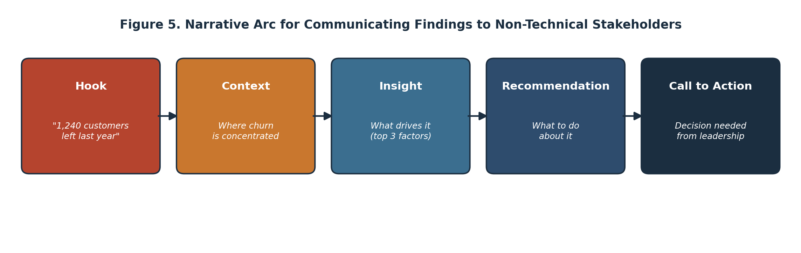
Figure 5. Narrative arc used to structure the stakeholder presentation.
Within that structure, the following techniques would be used to keep the presentation accessible:
- Open with a single concrete figure that frames the size of the problem (e.g., "1,240 customers left last month"), not a technical summary of the methodology.
- Translate every statistical result into a plain-language business statement (e.g., "customers who contact support twice or more are more than twice as likely to leave" rather than a coefficient or importance score).
- Limit each slide or section to one idea and one supporting visual; move detailed metrics (ROC-AUC, exact confusion-matrix counts) to an appendix for technical reviewers rather than the main narrative.
- Use consistent color coding throughout — warm colors for risk/above-average churn, cool colors for stable/below-average performance — so visual meaning transfers across every chart without re-explanation.
- Use named, specific customer examples (anonymized, as in Table 2) rather than only aggregate statistics, since a single concrete story is often more persuasive to a non-technical audience than a percentage.
- Close every insight with an explicit "so what": a recommended action tied directly to the finding, not just an observation.
- End with a single, specific decision or approval being requested, rather than a general list of options.

4. Expected Outcomes and Challenges

4.1 Expected Outcomes (Illustrative Estimate)
If the model is used to flag the top 5% of the active base each month (~1,000 customers), and the 52% test-set precision holds in production, approximately 520 of those flagged would be genuine at-risk customers reached proactively. If low-cost outreach converts even 20% of that group from "likely to cancel" to "retained" — a conservative assumption for a check-in email rather than a discount — this would preserve approximately 104 customers per month, or roughly 1,250 per year. At an average annual subscription value of $1,200, this represents an estimated $1.5M in protected annual recurring revenue, against an estimated $220,000/year cost for expanded outreach staffing capacity — a projected return of roughly 6.8x. These figures are order-of-magnitude estimates intended to size the opportunity, and should be refined once the A/B evaluation in Section 4.2 produces real conversion data.

4.2 Challenges and Concrete Scenarios
The following table walks through specific, realistic scenarios the team would need to manage during rollout, rather than only naming risks abstractly.
Table 3. Challenges illustrated with concrete scenarios.
Challenge | Concrete Scenario | Mitigation
Alert-volume mismatch with team capacity | Flagging the top 5% of the 20,000-customer base each month produces ~1,000 alerts/month; the retention team can realistically follow up on ~250/month. | Rank flagged customers by predicted probability × estimated account value, and route only the top 250 for white-glove outreach; route the remainder to a lighter-touch automated email.
Seasonal confounding of the retention-program result | The observed churn decline (7.1% → 4.3%) overlaps with Q4, when a historical seasonal dip of roughly 1–2 points has occurred in prior years around the November holiday promotion period. | Run a holdout group that does not receive the retention program for one quarter to isolate the program's true incremental effect from seasonality.
Data drift after deployment | A pricing change or new competitor entering the market could shift customer behavior enough that the model's 62.4% F1-score on the original test set no longer holds. | Recompute F1 monthly on a rolling 30-day outcome sample (~500 resolved cases); trigger a retraining review if F1 drops more than 10% relative to the 0.624 launch baseline (i.e., below ~0.56).
Low precision increases the cost of false alarms | At 52% precision, an outreach batch of 1,000 flagged customers includes roughly 480 who were not actually going to churn (see Customer #33089). | Reserve higher-cost interventions (e.g., discounts) for the highest-confidence tier (probability > 85%, ~145 customers/month) and use low-cost check-ins for the rest.

5. Recommendations for Future Work
Based on the insights above, the following actions are recommended, each with a named owner and a concrete target or timeframe rather than an open-ended commitment.
Table 4. Recommendations with targets and timeframes.
Recommendation | Rationale | Owner | Target / Timeframe
Launch a structured 90-day onboarding sequence | New customers churn at 11.4%, nearly double the average; this is the highest-leverage segment by volume (n=2,400/month). | Customer Success | Pilot with 500 new customers within 30 days; target a 3-point reduction in this segment's churn within one quarter.
Route repeat support contacts to a retention specialist | Support-ticket frequency is the top churn predictor (21% importance); faster, higher-touch response could reduce escalation to cancellation. | Support Operations | Roll out to customers with 2+ tickets/90 days within 6 weeks.
Deploy engagement-decline alerts to the retention team | Login-frequency drops are visible 2–4 weeks before cancellation (see Customer #48213), creating a proactive-outreach window. | Data/Analytics Team | Automated weekly alert live within 45 days.
Run a controlled A/B evaluation of the retention program | The observed improvement overlaps with a historically low-churn quarter; a holdout group is needed to isolate the program's true effect. | Data Science Team | Design finalized within 2 weeks; run for one full quarter.
Establish a monthly model-monitoring review | Customer behavior evolves; a fixed F1 trigger (below ~0.56) protects against silent performance decay. | Data Science Team | First review scheduled 30 days post-launch, then monthly.

Beyond these immediate actions, two longer-term extensions are worth scoping within the next two quarters: expanding the model to estimate expected revenue at risk per flagged customer (rather than churn probability alone), which would let the retention team prioritize the ~1,000 monthly alerts by dollar impact rather than treating them uniformly; and testing whether earlier-warning models (60- or 90-day horizons) preserve enough of the current 0.84 AUC to extend the intervention window beyond the current 21-day median lead time observed in cases like Customer #48213.

6. Report Development Planning Process
This report itself was produced using a structured five-day, 34-hour planning cycle, illustrated in Figure 6, so that the process is auditable and repeatable for future reporting cycles rather than ad hoc.
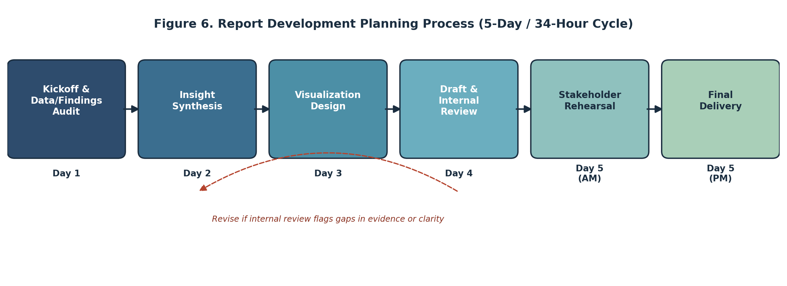
Figure 6. Report development planning process, including the revision loop between drafting and review.
Each stage in Figure 6 corresponds to a specific day and produces a defined output: the Day 1 data/findings audit produces a verified set of source numbers; Day 2 insight synthesis produces the ranked findings list and case studies; Day 3 visualization design produces the five analytical figures; Day 4 produces the narrative, recommendations, and process diagrams; and Day 5 is reserved for review, rehearsal, and final polish. The dashed revision loop reflects that internal review on Day 4 can send work back to insight synthesis or visualization design if evidence gaps or unclear charts are identified, rather than assuming the first draft of each stage is final.

7. Detailed Timeline and Work Allocation
Table 5 and Figure 7 break the 34-hour, 5-day plan down into 15 individually scoped tasks, replacing a single hours-per-section estimate with task-level granularity.
Table 5. Detailed day-by-day task timeline.
Day | Task | Hours | Report Section
Day 1 | Kickoff call and confirm the three key messages for the report | 1.5 | Executive Summary
Day 1 | Audit prior analysis findings and model outputs for accuracy | 2.0 | Methodology
Day 1 | Draft methodology overview in plain, non-technical language | 3.5 | Methodology
Day 2 | Synthesize findings into a ranked list by business impact | 2.5 | Insights & Analysis
Day 2 | Identify and write up 2 supporting customer case studies | 2.0 | Insights & Analysis
Day 2 | Draft the findings summary table with concrete figures | 2.5 | Insights & Analysis
Day 3 | Build churn-trend and feature-importance charts | 3.0 | Insights & Analysis
Day 3 | Build ROC-curve/confusion-matrix and segment charts | 2.5 | Insights & Analysis
Day 3 | Write visualization rationale and figure captions | 1.5 | Insights & Analysis
Day 4 | Design the narrative arc and presentation strategy | 2.5 | Presentation Strategy
Day 4 | Draft recommendations with owners and target timeframes | 2.5 | Recommendations
Day 4 | Build the planning-process flowchart and Gantt timeline | 2.0 | Documentation
Day 5 (AM) | Internal review and stakeholder rehearsal | 2.0 | Documentation
Day 5 (PM) | Formatting, proofreading, and final polish | 2.0 | Documentation
Day 5 (PM) | Buffer reserved for last-minute revisions | 2.0 | Documentation

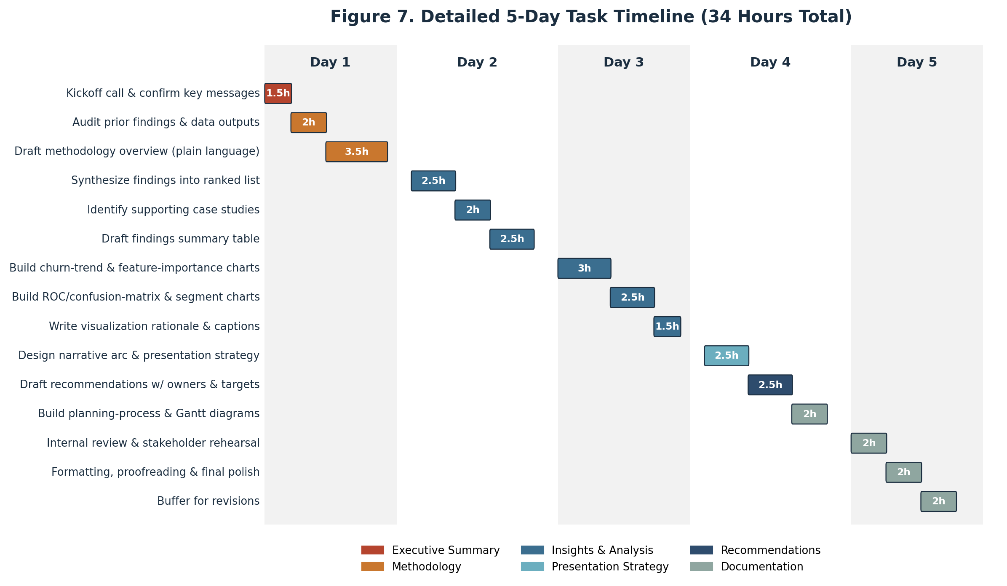
Figure 7. Gantt-style view of the same 15 tasks, showing sequencing and duration within each day.

8. Visualization Rationale
Table 6 documents why each visual in this report was chosen over alternative chart types, so the choices are traceable rather than incidental.
Table 6. Visualization rationale.
Visualization | Chart Type | Why This Choice
Monthly churn trend | Line chart with benchmark reference and event annotation | Line charts are the clearest way to show a trend over time; the benchmark line and program-launch marker let viewers judge performance and cause-and-effect at a glance.
Feature importance | Horizontal bar chart, sorted | Sorted horizontal bars make ranking immediately visible and scale well to longer feature labels than a vertical layout would.
Model performance | ROC curve and confusion matrix, paired | The ROC curve summarizes overall discriminative power for technical reviewers, while the confusion matrix translates that performance into concrete counts a business audience can sanity-check.
Segment comparison | Vertical bar chart with reference line | Bars with a shared baseline make it easy to compare churn rates across segments; color-coding above/below average adds a second layer of meaning without extra text.
Presentation structure | Horizontal narrative-flow diagram | A five-stage flow visually reinforces the storytelling sequence used to walk stakeholders from problem to decision.
Report planning process | Horizontal process flowchart with day labels | Makes the report's own production timeline auditable and repeatable, and shows exactly where revision loops occur.
Detailed task timeline | Gantt-style horizontal timeline, color-coded by section | Shows task-level duration and sequencing within each day, which a simple table of hours cannot convey.

9. Conclusion
This report consolidates a customer churn analysis into a single, decision-ready narrative for executive review, grounded throughout in concrete counts rather than abstractions: a 20,000-customer base, an 0.84 AUC model validated on a 3,000-customer held-out test set, named customer-level examples, and a fully scoped 15-task production timeline. It shows not only that churn can be predicted with strong reliability, but why customers leave, which of the 5,350 at-risk customer-slots carry the greatest priority, what specific, time-bound actions would address that risk, and what could go wrong along the way. Paired with a structured presentation strategy built for a non-technical audience and an auditable planning process, this report is intended to move stakeholders efficiently from insight to informed decision, and to establish a repeatable template for how future analytical findings from this project should be communicated across the organization.

